**"Butterfly - *Arts into Education*" Erasmus +**

**Monday:**

**At Ørding friskole**

**09:00 – 10:30**

Activities around the Butterfly Project- Platforms, formalities, methods etc. –

**10:30 – 13:30**

The method behind our project - Charlotte makes a presentation as well as a reading with Gerd Laugesen from her book Meetings. A prelude to the workshop on Wednesday.

**13:30**

Lunch from Kaffehjørnet –Charlotte takes orders.

**14:30 – 15:30**

Recap of the day.

**18:00-21.00**

Dinner 100 kroners pr. Person+ drinks:

Cultural feature at Kulturkøbmanden/an independent café.

A small welcome and presentation of the place by Hanne.

Dinner

“Conversation-café”

**Kulturkøbmanden**

**Staghøjmøllevej 23, Sillerslev**

**7990 Øster Assels**

**Tuesday:**

**09:00 – 13:00**

Presentation and tour of Ørding Friskole by Hanne & teachers

Coffee break + time to explore the different theatre activities taking place at the school.

Complementary lunch at school, a traditional Danish menu prepared by members of the community.

Children and grown-ups dine together.

Ørding friskole/Carpark opposite church

Skolesvinget 9, Ørding

7990 Øster Assels

**Kl. 14:00 -15:00**

Workshop with Professor Hanne Kudsk at VIA University College.

On “Butterfly methods.”

Coffee and cake at the College.

VIA University College-Thisted

Lerpyttevej 43

7700 Thisted

Evening: Free night to explore Nykøbing Mors-Check out the local cinema.

**Wednesday:**

**10:00-13:00**

Morning

Workshop on the subject “Meetings” by Charlotte

At Café Holmen

Situated at the harbour in Nykøbing.

Jernbanevej 3, 7900 Nykøbing Mors

**13:00**

Lunch at Café Holmen.

Non complementary-choice by menu.

Afternoon:

**13:50-15:30**

Tour of Jesperhus Butterfly Garden with butterfly expert.

Complementary.

Jesperhus Flowerpark

Legindvej 30

7900 Nykøbing Mors

Dining: Choice of 5 small restaurants/cafés Nykøbing Mors.

Evening

**19:00**

Tour of The New Limfjord Theatre by Gitta Malling

The new Limfjord Theatre

Limfjordsvej 95, 7900 Nykøbing Mors

**Thursday**:

**9:30** Complementary coffee and bread at Ørding School.

**10:00 – 10:45**

Dress rehearsal

Children´s theatre performance at Ørding School

Lunch

Non complementary - sandwich from Kaffehjørnet -Charlotte takes your orders

Afternoon

**14:00 – 17:00**

A visit to Fossil Museum and Hanklit – Complementary.

A guided tour by Henrik Andersen.

Fossil Museum

Skarrehagevej 8, Sejerslev

7900 Nykøbing Mors

Hanklit – 55 million year old fossil embankment.

Nature walks both on and below.

Hanklitvej -7900 Nykøbing Mors

Evening Free

Thisted – Skive both half an hour away.

**Friday**:

Morning:

At Ørding School

Recap of the week.

Workshop.

Next step Butterfly Project Dec. 2019?

Goodbye dinner/Packing/returning home.

Non complementary.

Dinner possibly at Sallingsund Færgekro

Sallingsund Færgekro

Sallingsundvej 104, Nykøbing Mors

**Contact details**

Charlotte-0045-22414311

Hanne 0045-27841078

Ørding School-0045-97766102

**Important stuff for the accommodation:**

Six people in the house of the theatre:

Maria, Gabriele, Juanjo, Sebastian, Monica, Isabel

Isabel and Juanjo will arrive to Aalborg on 7th, 14:35 – car rent? We are not avalible☹

and back on 9th, 20:30, from Aalborg, Monica and Isabel will need two rooms, just for two nights (7-8 / April).

Sebastian and Juanjo will need two rooms on April 7-11.

Natalia and Antonio stay in an apartment for the week and rent a car.

The address for the house/accommodation by the Limfjord Theatre:

Skolegade 25

7900 Nykøbing Mors

[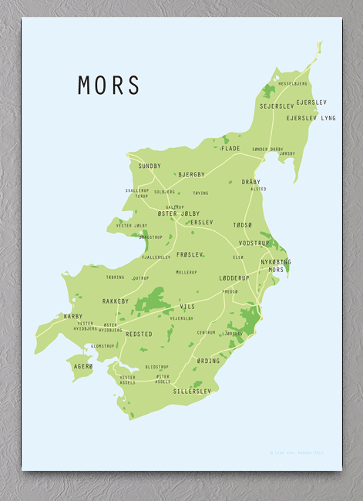](https://www.google.dk/url?sa=i&rct=j&q=&esrc=s&source=images&cd=&cad=rja&uact=8&ved=2ahUKEwiGgtr78prhAhWSyKYKHdFeCgIQjRx6BAgBEAU&url=https://nova-natura.dk/produkt/mors-kort-plakat/&psig=AOvVaw00aRgdnDc-r1MNZiLJn1G5&ust=1553521025931038)